## GIT EXERCISE 5:

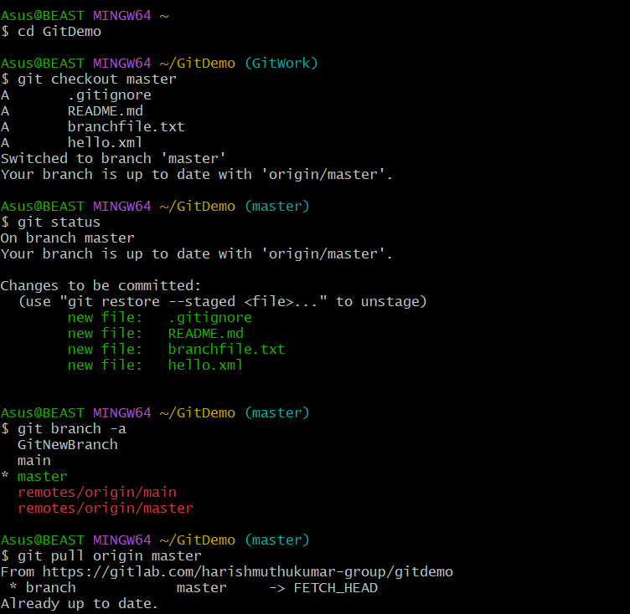

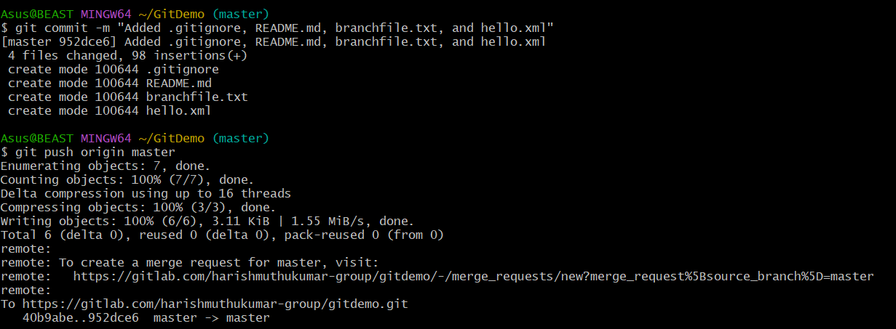

**Objectives :**

Explain how to clean up and push back to remote Git

**Steps:**

1. **Remove untracked files and directories**

git clean -fd

*-f forces removal, -d removes untracked directories.*

1. **Discard local changes to tracked files**

git reset --hard

1. **Delete unused local branches**

bash

CopyEdit

git branch -d branch_name

1. **Pull the latest changes from remote to ensure sync**

git pull origin main

1. **Push the cleaned state to remote**

git push origin main